**.NET Application Programming**

**Project Status and Design Report**

|  |  |  |
| --- | --- | --- |
| **Topic:** | *FR4, FR4.5* | |
| **Date:** | *10-01-2020* | |
| **Revision:** | *3.0* | |
| **Team:** | 1. *Matt Sievers* | |
| 1. Crystal Sciarrino | |
|  | |
|  | |
| **Weekly Team Status Summary:** | |  |  |  |  | | --- | --- | --- | --- | | **User Story** | **Team**  **Member** | **Hours**  **Worked** | **Hours Remaining** | | As a developer, I need to update the registration page password to show *** | *Crystal Sciarrino* | *2* | *0* | | As a team, the weekly team paperwork deliverables need to be completed | *Matt Sievers / Crystal Sciarrino* | *2* | *0* | | As a developer, I need to update the Login page password to show *** | *Crystal Sciarrino* | *2* | *0* | | As a developer I need to create the board model | *Matt Sievers* | *1* | *0* | | As a developer I need to create the cell model | *Matt Sievers* | *1* | *0* | | As a developer I need to create the GameBoardController (GBC) | *Matt Sievers* | *4* | *0* | | As a developer I need to add validation to the models for entry on the registration page | *Crystal Sciarrino* | *4* | *0* | | As a developer I need to add validation to the models for entry on the Login page | *Crystal Sciarrino* | *2* | *0* | | As a developer, I need to update GBC to populate and build the game board into a 2d array to use in a table on the view | *Matt Sievers* | *2* | *0* | | As a developer, I need an OnClick() method to help determine which button was clicked on the game board. Add simple logic to add a bomb image for live==true and if not show neighbors value (if 0 "") | *Matt Sievers* | *2* | *0* | | As a team, we need to create week 3 user stories | *Matt Sievers / Cryatal Sciarrino* | *1* | *0* | | As a developer, I need a new folder to house images used for the game | *Matt Sievers* | *1* | *0* | | As a developer I need a new view created to select difficulty. Three buttons, easy, moderate, hard are required to set the game board live cells. | *Matt Sievers* | *1* | *0* | | As a developer, I need to add the DifficultyClick() to GBC. | *Matt Sievers* | *2* | *0* | | As a developer, I need to update the workflow so that the registration and login pages land on the right pages now. Registration -> Login -> Difficulty | *Crystal Sciarrino* | *1* | *0* | | As a developer, I need to remove un needed views. | *Crystal Sciarrino* | *1* | *0* | | |
| **GIT URL:** | https://github.com/Malleas/CLCMinesweeperApp | |
| **Peer Review:** | *Y* | We acknowledge that our team has reviewed this Report and we agree to the approach we are all taking. |

**Planning Documentation**

**Agile Scrum Board:**

[**https://www.meistertask.com/app/project/sSO4jU4u/cst-247**](https://www.meistertask.com/app/project/sSO4jU4u/cst-247)

**Agile Scrum Product Backlog:**

<https://github.com/Malleas/CLCMinesweeperApp/tree/master/CLCMinesweeperApp/Planning%20and%20Design/Week%202>

**Agile Scrum Sprint Backlog:**

[*https://github.com/Malleas/CLCMinesweeperApp/tree/master/CLCMinesweeperApp/Planning%20and%20Design/Week%202*](https://github.com/Malleas/CLCMinesweeperApp/tree/master/CLCMinesweeperApp/Planning%20and%20Design/Week%202)

**Agile Scrum Burn Down Chart:**

[*https://github.com/Malleas/CLCMinesweeperApp/tree/master/CLCMinesweeperApp/Planning%20and%20Design/Week%202*](https://github.com/Malleas/CLCMinesweeperApp/tree/master/CLCMinesweeperApp/Planning%20and%20Design/Week%202)

**Agile Retrospective Results:**

*The following table should be completed after each Retrospective on Things That Went Well (Keep Doing). An alternative to the following table is to use a Mind Mapping tool such as Coggle. If you use a Mind Mapping tool you must include a URL or Image File.*

|  |
| --- |
| **What Went Well** |
| **Was able to get DB installed on Crystal system for both CLC and Assigments** |
| **Great working sessions as we did peer coding.** |
|  |

*The following table should be completed after each Retrospective on Things That Didn’t Go Well (Stop Doing) and What Would Be Done Differently Next Time with an Action Plan to Improve (Try Doing and Continuous Improvement). An alternative to the following table is to use a Mind Mapping tool such as Coggle. If you use a Mind Mapping tool you must include a URL or Image File.*

|  |  |  |
| --- | --- | --- |
| **What Did Not Go Well** | **Action Plan** | **Due Date** |
| Both of us had limited time this week so there was lots of cramming | None, just busy week for non-school related work. |  |
| **Requirements changed for FR4 from the scope docs** | **Start to read ahead for upcoming weeks.** | **10/10/20** |
|  |  |  |

**Design Documentation**

**Install Instructions:**

*Connect and pull from master from repo. Refer to DDL scripts before running as a local DB will need to be created and table added. Click debug menu option and select Run without debug. Backup provided of DB for full install as needed.*

**General Technical Approach:**

*As a team we wanted to mimic the original flow of the app from CST227. We also wanted to ensure that the workflow was correct post registration page. Most of this week’s project was related to reusing the old code we had into a new type of format.*

**Key Technical Design Decisions:**

*Reusing CST227 code. Adding everything from Cell, Board helped in the initial setup. Mimicking how we did the assignment and passing the Model.Cell and Model.Row from the view into the name for the button that was clicked helped identify it within the controller for easy logic integration.*

**ER Diagram:**

*n/a for this requirement*

**DDL Scripts:**

*CREATE TABLE [dbo].[Player]*

*(*

*[USERID] INT NOT NULL PRIMARY KEY IDENTITY(1,1),*

*[FIRSTNAME] VARCHAR(50) NOT NULL,*

*[LASTNAME] VARCHAR(50) NOT NULL,*

*[GENDER] VARCHAR(50) NOT NULL,*

*[AGE] INT NOT NULL,*

*[STATE] VARCHAR(2) NOT NULL,*

*[EMAILADDRESS] VARCHAR(100) NOT NULL,*

*[USERNAME] VARCHAR(50) NOT NULL,*

*[PASSWORD] VARCHAR(50) NOT NULL*

*)*

**Sitemap Diagram:**

*N/A not required for this FR*

**Security Design:**

*Field validation was added in this FR as well as making the password only show ***. Some sort of hashing will be required for saving to DB, but that will come later.*

**Third Part Interface Design:**

*NA*

**Flow Charts:**

*NA*

**User Interface Diagrams:**

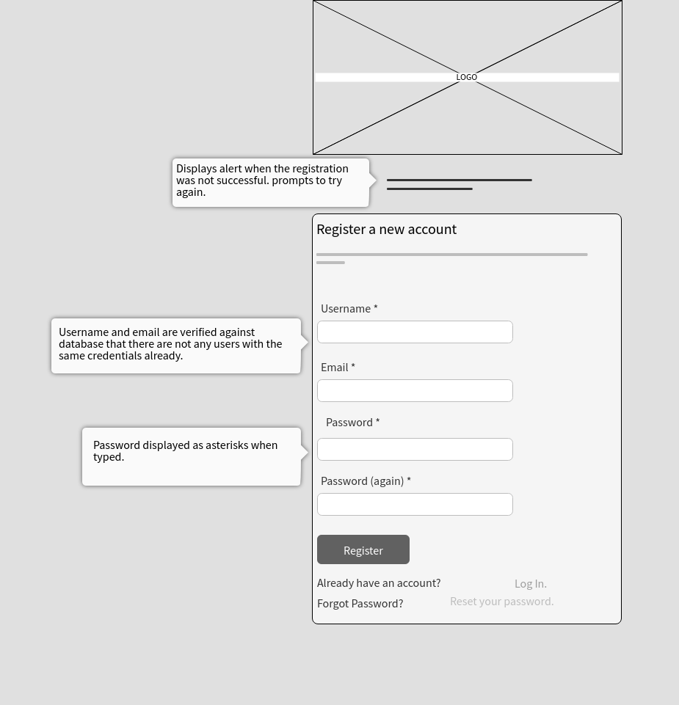

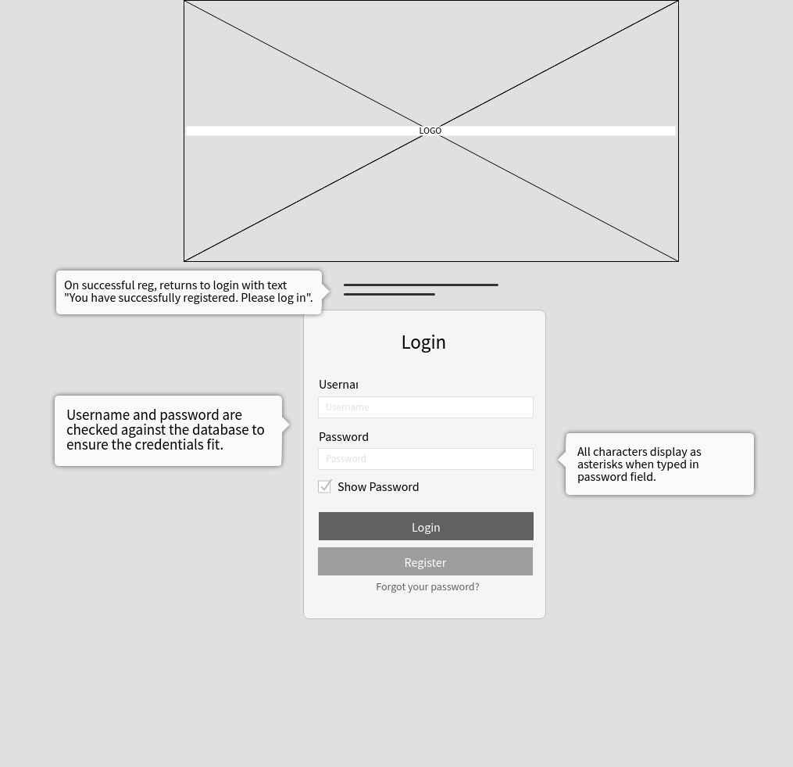

**Class Diagrams:**

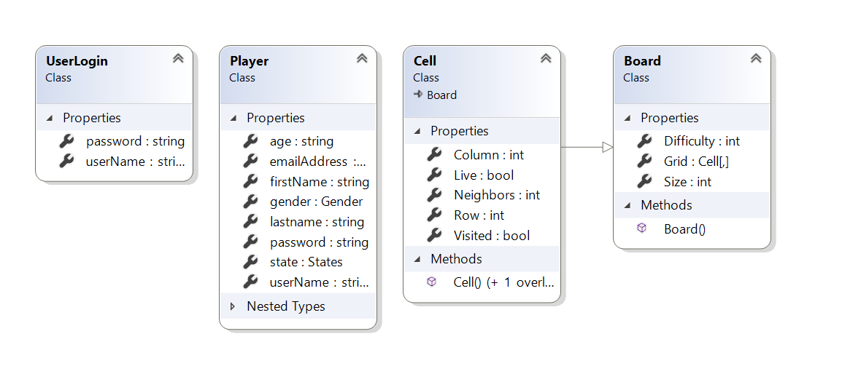

**Pseudo Code:**

*N/A*

**Other Documentation:**

*N/A*